**DAILY ONLINE ACTIVITIES SUMMARY**

|  |  |  |  |  |  |  |
| --- | --- | --- | --- | --- | --- | --- |
| **Date:** | **26/05/2020** | | | **Name:** | **JASLINE SHARON TAURO** | |
| **Sem & Sec** | **4th sem, A Section** | | | **USN:** | **4AL18CS029** | |
| **Online Test Summary** | | | | | | |
| **Subject** | | **DESIGN AND ANALYSIS OF ALGORITHMS** | | | | |
| **Max. Marks** | | **30** | | **Score** | **28** | |
| **Certification Course Summary** | | | | | | |
| **Course** | 1. **STEPathon-communication skills [ICT ACEDAMY]** 2. **Introduction to IoT** | | | | | |
| **Certificate Provider** | | | **1.THE HINDU**  **2.CISCO ACADEMY** | **Duration:** | | 1. **2 hrs.** 2. **2 hrs.** |
| **Coding Challenges** | | | | | | |
| **Problem Statement:** 1. Given an array A of size N where the array elements contain values from 1 to N with duplicates, the task is to find total number of subarrays which start and end with the same element.  2.Write a program in C to print all permutations of a given string using pointers  3. Write a JAVA Program to remove all the Tens in the given array | | | | | | |
| **Status: DONE** | | | | | | |
| **Uploaded the report in GitHub** | | | | **YES** | | |
| **If yes Repository name** | | | | [**https://github.com/jaslinesharontauro/C_Prgms**](https://github.com/jaslinesharontauro/C_Prgms)  <https://github.com/jaslinesharontauro/JAVA_Prgms> | | |
| **Uploaded the report in slack** | | | | **YES** | | |

**Online Test Details: (Attach the snapshot and briefly write the report for the same)**

**Certification Course Details: (Attach the snapshot and briefly write the report for the same)**

**Coding Challenges Details: (Attach the snapshot and briefly write the report for the same)**

**1.ONLINE TEST DETAILS:**

**Today we had assessment in the subject DESIGN AND ANALYSIS OF ALGORITHM it was based on second module of this subject. There were total 30 number of questions of ONE mark each.**

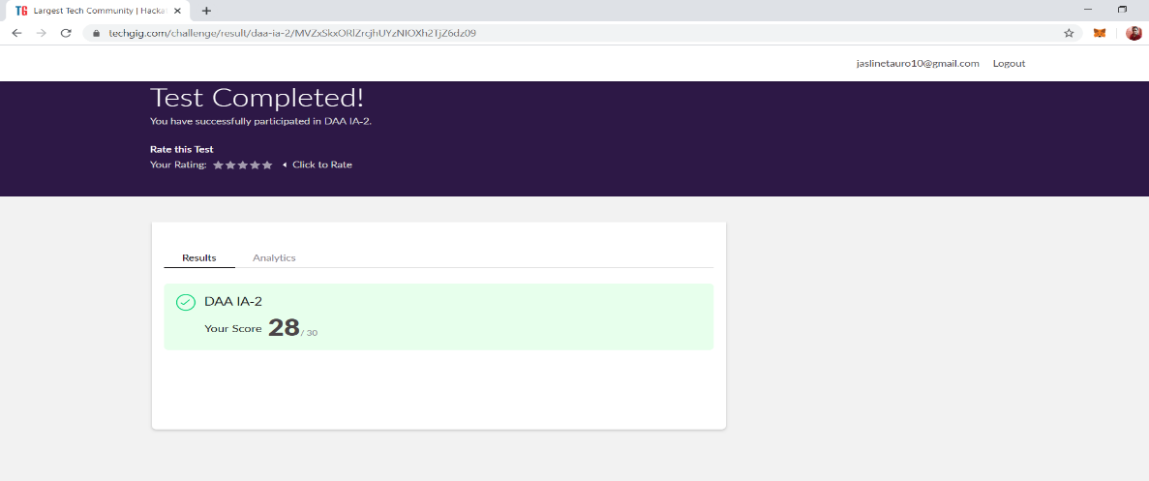

**2.CERTIFICATION COURSE DETAILS**

I had done this certification course on 25/05/2020 this course is based on communication skills i.e., “THE STEPathon9” by The Hindu group. This course has a series of video-based webisodes or lessons which form an exciting story about a group of friends as they take a trip across India. Each webisode focuses on various language skills like reading, writing, listening, speaking, grammar, vocabulary. Today I have successfully completed this course

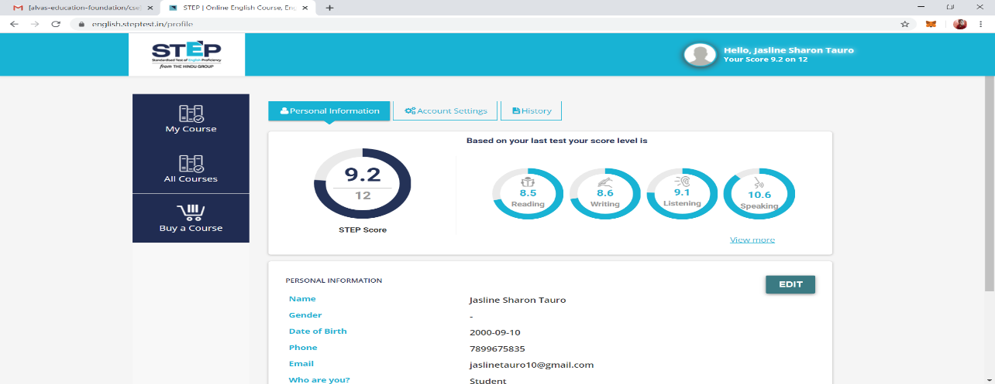

**Today I have started a new certification course on INTRODUCTION TO IoT By CISCO NETWORKING ACADEMY.** This Introduction to Internet of Things 2.0 course is designed for people wishing to explore the Internet of Things and the impact it has on our everyday lives. It is not the intention of this course to teach about the IoT in depth but to provide a general understanding of the IoT and how it allows for digitization of daily tasks.

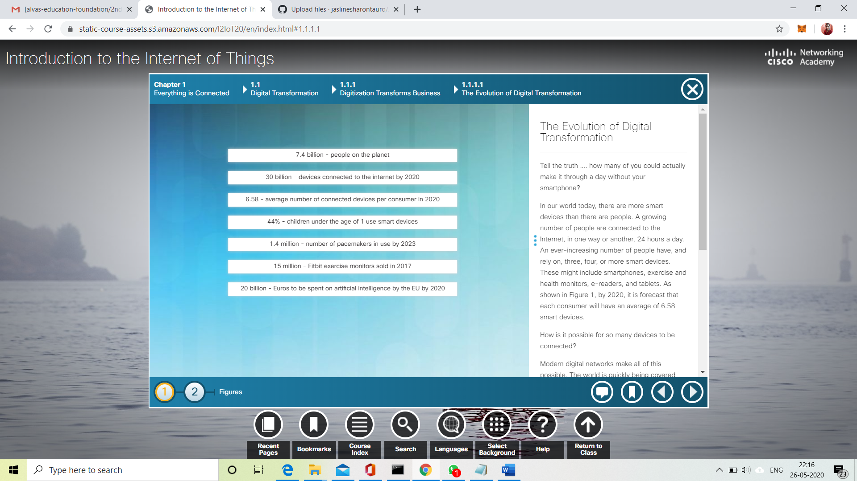

**3.CODING CHALLENGES DETAILS:**

**Problem statement 1:**

Given an array A of size N where the array elements contain values from 1 to N with duplicates, the task is to find total number of subarrays which start and end with the same element.

examples:

Input: A[] = {1, 2, 1, 5, 2}  
 Output: 7  
 Explanation:  
 Total 7 sub-array of the given array are {1}, {2}, {1}, {5}, {2}, {1, 2, 1} and {2, 1, 5, 2} are start and end with same element.

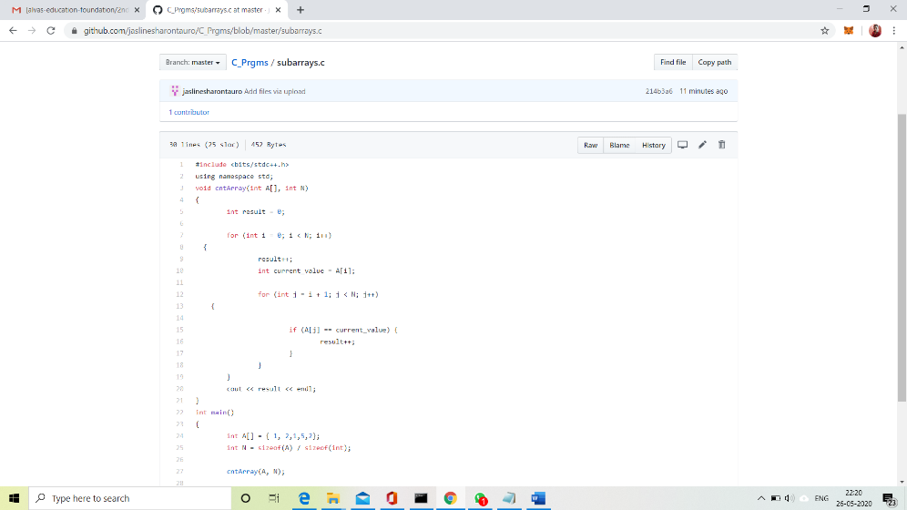

**Solution: Uploaded it in GitHub**

**Problem Statement 2:**

Write a program in C to print all permutations of a given string using pointers.

The permutations of the string are:  
abcd abdc acbd acdb adcb adbc bacd badc bcad bcda bdca bdac cbad cbda cabd cadb cdab cdba dbca dbac dcba dcab dacb dabc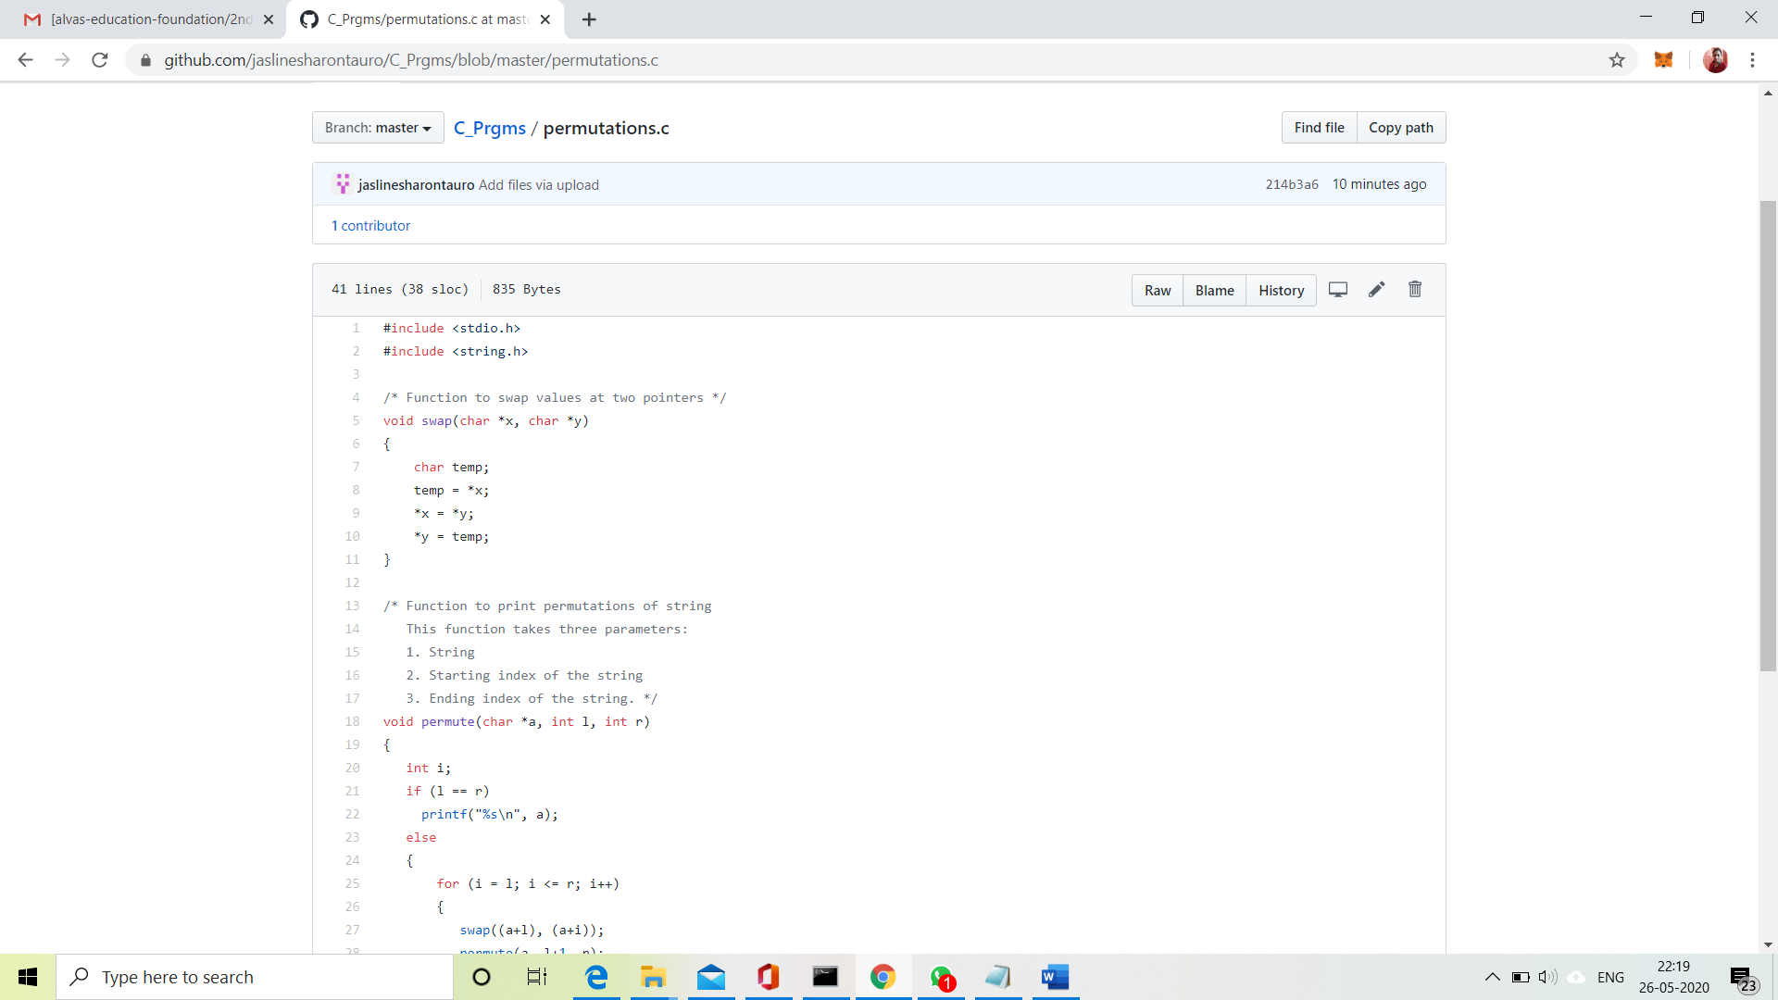

**Solution: Uploaded it in GitHub**

**Problem Statement 3:**

Write a JAVA Program to remove all the Tens in the given array

Return a version of the given array where all the 10's have been removed. The remaining elements should shift left towards the start of the array as needed, and the empty spaces the end of the array should be 0. So {1, 10, 10, 2} yields {1, 2, 0, 0}. You may modify and return the given array or make a new array.  
**Example**  
withoutTen ([1, 10, 10, 2]) → [1, 2, 0, 0]  
withoutTen ([10, 2, 10]) → [2, 0, 0]

Input: First line should read number of array elements. Second Line should read the array elements which includes atleast two 10.

Output: Array which contains elements without 10. **Refer the examples.**

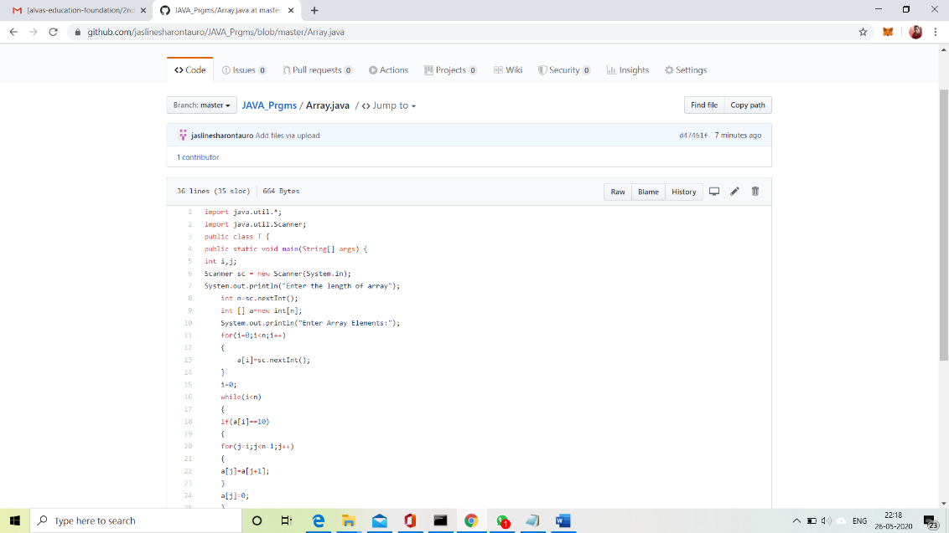

**Solution: Uploaded it in GitHub**